Verify Check  Cab  Cleanliness  Seat condition OK  Operator restraint provided  Instruments operational & labeled  Levers / controls operational  Pedals in good condition  ROPS to AS 2294  Windows / wipers / washers  Rear view mirrors  Operator instruction  (available on plant)  Warning devices  Verify Check  Horn  Reversing alarm  Verify Check  Warning signs (in cabin)  SEAT BELTS MUST BE WORN | Supplier verification & Plant details
 | Plant owner:
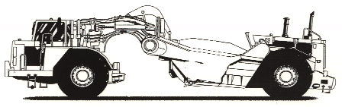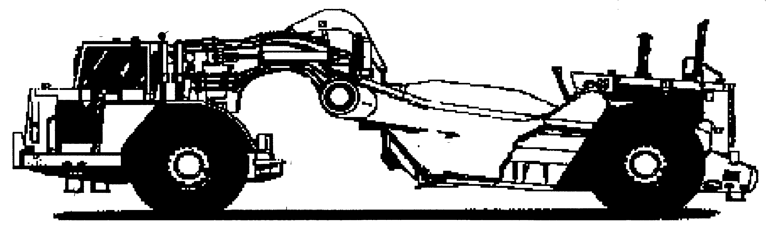 | Address:
 | City/Suburb:
Verify Check  Pivots  Connecting rods  Safety pins  (no excessive wear) | Phone:
Verify Check  Exhaust  Verify Check  Exhaust | Plant make:
 | Plant model:
 | Serial no.:
 | Signature:
 | Date:
 | Statement of operator competence required
 Plant to conform to manufacturer’s specifications and Plant Regulations.
 Plant operator is to provide daily checksheets to WDA on a weekly basis
 Where applicable, Personal Protective Equipment must be worn.
 Plant Log Book detailing service history in accordance with Manufacturer’s specifications should be written legibly in English.
 Contractor must produce proof of competence of operator, e.g., Certificate of Competence, Licence, detailed Log Book
Verify Check  Handrails  Steps  Hydraulics  Verify Check  Rams  Hoses  Connections  (check for excessive  wear, leaks and creep)  Verify Check  Tyres  Wheels  Brakes  Park brake | WDA use only
 | Note: Sign only when all items have been checked
 | Plant check by:
Instructions:  Verify Box to be ticked by Owner / Supplier / Operator prior to arrival onsite.  Check Box to be ticked after visual inspection by WDA | Position:
Note : to be registered if used on public roads | Date: |  | / /

